Uninstalling and Reinstalling Unplug’d
Unplug’d is the software used to wirelessly connect your device to a panel. It will need to be loaded on every computer you plan to use. As some computers may already have an older version of Unplug’d, you first need to run an uninstaller and then install Unplug’d. Directions for both are below:
Directions for: running the Uninstaller for Unplug’d from Software Center
From your Windows Task Bar:  - Click the Windows icon  - Start typing “Software Center”  - Click “Open” | 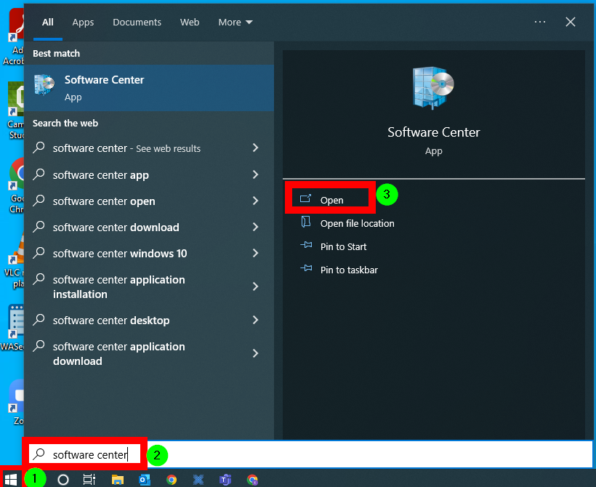
In the “Applications” tab, locate the Unplug’d Uninstaller.  Look for: UNINSTALL Unplug’d 2.1.1120 | 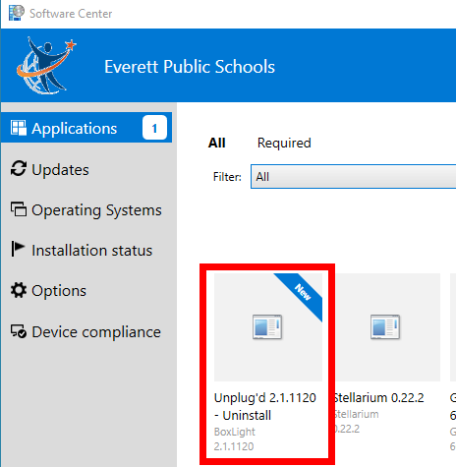
Click “Install.”  The application will Uninstall the previous version of Unplug’d.  The application is done when it says “Reinstall.” (You do not need to click this.) | 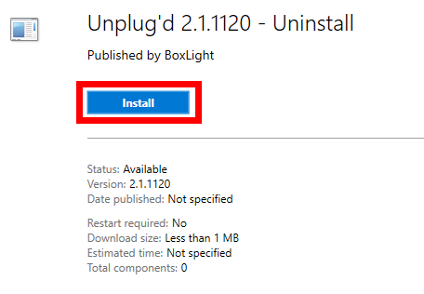
You may have to run updates BEFORE you can install software.  If this is the case, in Software Center go to the “Updates” tab, and click “Install All.” | 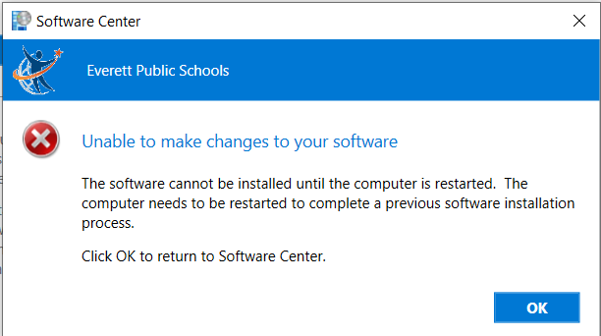

Directions for installing the new version of Unplug’d from Software Center
From your Windows Task Bar:
- Click the Windows icon
- Start typing “Software Center”
- Click “Open”

In the “Applications” tab, locate the Unplug’d app.  Look for: Unplug’d 2.2.1109 - Unplug’d  *Note: Do not run the Uninstaller again. | 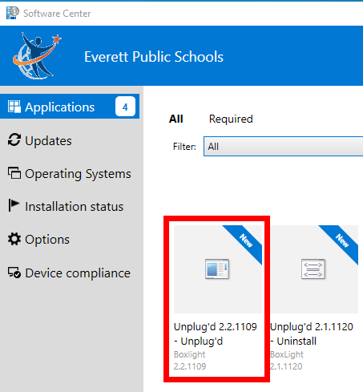
Click “Install.”  The application is done when it says “Reinstall.” | 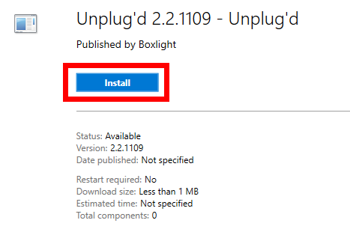
Once complete, the application will create a new shortcut on your desktop. | 